Creating the Methods (Add)
Completing the Collection Class

Completing the Collection Class 1
ThisAddress 1
Creating the Add Method 3

Completing the Collection Class

ThisAddress
At this point it is worth thinking about how the property ThisAddress is going to work and how it relates to the methods Add, Update and Delete.
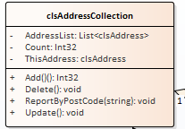
ThisAddress is an instance of clsAddress which we have already seen looks like this...
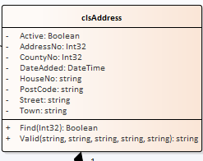
The find method allows us to search for a specific address based on its primary key value.
Assuming we have the following data...
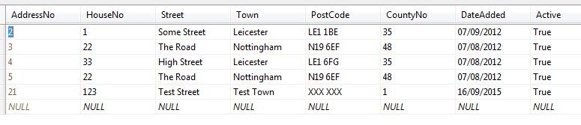
The following code...
clsAddress SomeAddress = new clsAddress();
SomeAddress.Find(3);
Would locate the second record in the list setting the values of the properties of SomeAddress to match the data stored in the record.
We can use the find method of clsAddress via any instances of clsAddressCollection.
Compare the following code...
clsAddressCollection AllAddresses = new clsAddressCollection();
AllAddresses.ThisAddress.Find(3);
This code would achieve the same outcome as the previous code example.
Having the ThisAddress property allows us to point to any address we want to do something to, by searching on its primary key.
Once we are pointing at a specific record we may use Add, Update and Delete to change the data pointed to by ThisAddress.
So...
clsAddressCollection AllAddresses = new clsAddressCollection();
AllAddresses.ThisAddress.Find(3);
AllAddresses.Delete();
Would delete the address with the primary key value of 3.
Or...
clsAddressCollection AllAddresses = new clsAddressCollection();
AllAddresses.ThisAddress.Find(3);
AllAddresses.ThisAddress.HouseNo = "22";
AllAddresses.Update();
Would set the value of HouseNo for record 3 to "22".
Or...
clsAddressCollection AllAddresses = new clsAddressCollection();
AllAddresses.ThisAddress.Active = true;
AllAddresses.ThisAddress.CountyNo = 1;
AllAddresses.ThisAddress.DateAdded = DateTime.Now.Date;
AllAddresses.ThisAddress.HouseNo = "22";
AllAddresses.ThisAddress.PostCode = "LE1 1WE";
AllAddresses.ThisAddress.Street = "Some Street";
AllAddresses.ThisAddress.Town = "Some Town";
AllAddresses.Add();
Would add a new record based on the data we assigned to ThisAddress. (Note in this example Find isn’t required.)

Creating the Add Method
Remember to start your Git Hub day!
Here is the test method for Add…
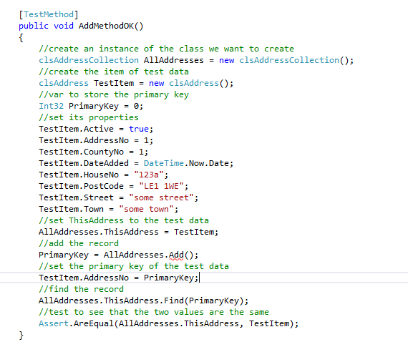
We have created rather more code here than usual. As we create more of the system and our confidence increases, we have the option to make bigger steps.
Notice what we are trying to do here:
- Create the collection
- Create some test data
- Use the test data to set the ThisAddress property
- Add the record to the database retrieving the primary key of the new record
- Find the record to check that it exists
- Compare the data found with the original test data (they should be the same)!

Run the test and watch it fail.
Create the Add method and the test will still fail!
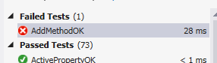
Why? It is because we don’t have any suitable code in the class to implement the method.
Currently the auto generated Add method in clsAddressCollection will look like this
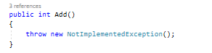
To fix this we will need to make a few changes to the code.
We will need to create a new private data member, modify the ThisAddress property and finally add some code to the Add method.
First let’s create the private data member for ThisAddress at the top of the class…
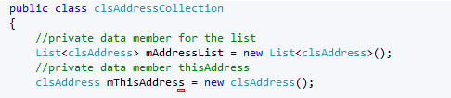
Next, we expose the private data member by modifying the public property from this…
To this…
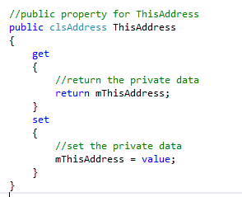
Lastly, we put a fix in the Add method to force the test to pass…
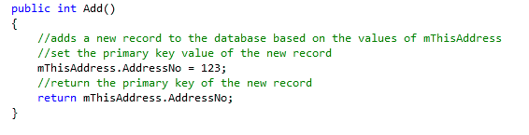
The good news is that it forces the test to pass. The bad news is that the code is pretty rubbish!
It would make more sense now to refine the code to make it actually work.
Assuming we have the following table…
Along with the following stored procedure…
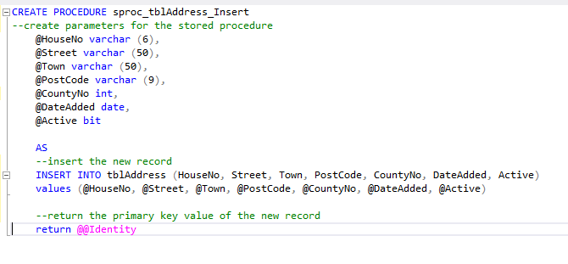
It is important to remember when adding a new record that the primary key is read-only and generated by the system. Notice how I do not include AddressNo, my primary key in the above SQL.
The amended function for Add should do the trick…
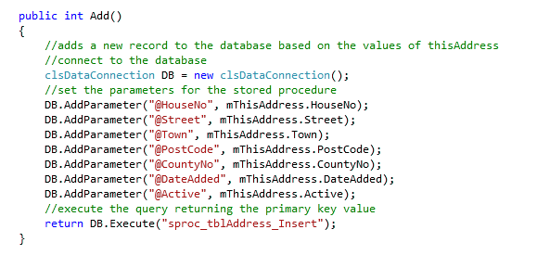
Lastly by examining the database we are able to see that a new record has been added…
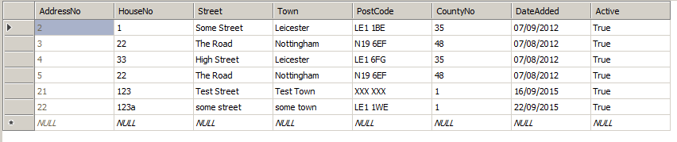
Having created the testing and the code for the Add method let’s add this to the presentation layer.
Open the form AddressBookList.aspx we created in the last section of work…
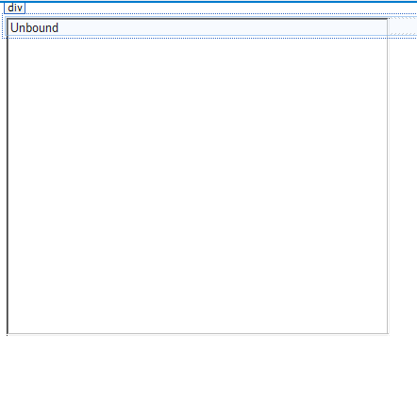
Below the list add a new button for Add with a label of btnAdd like so…
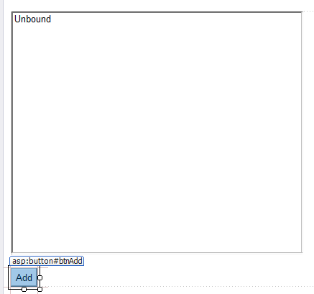

And access the event handler for the button’s click event…
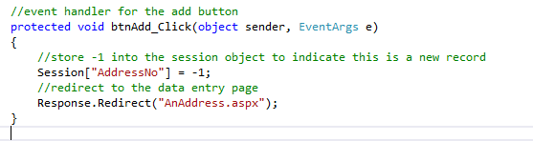
Notice how a value of -1 is placed in the session object on the server. What we need to do is send a message to the editing form AnAddress.aspx that this an add operation. That way when we press OK on the editing form…
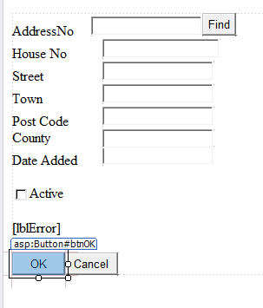
The system knows to add the inputted data as a new record.
(Make a mental note of this as we shall return to it when we implement delete and update)
Next, modify the event handler in AddressBookDataEntry.aspx for the OK button like so…
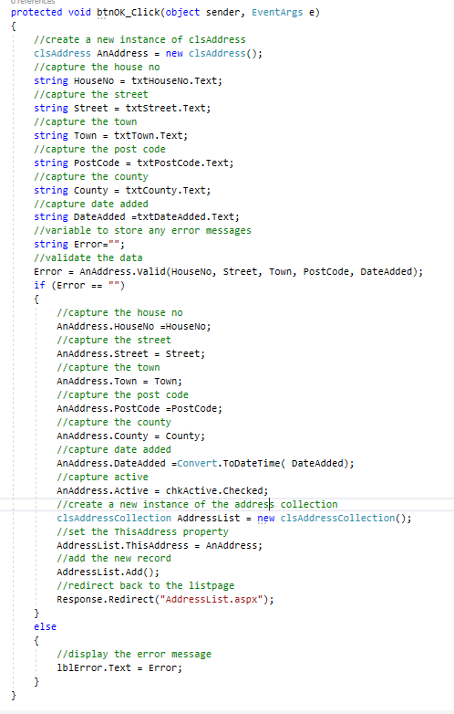
Run the program to see if you can add new records using the interface.
Finally end your Git Hub day.

